Ahsanullah University of Science and Technology (AUST)

Bangladesh

Outcome-Based Education (OBE) Curriculum for

Bachelor of Science in {name of the program} Engineering

March 2020

Table of Contents

Part A: Program Specific Information
Part B: Course-related Information
Part C: Course Outlines
Part D: Course Evaluation-related Information
Appendices
Appendix-A: Blooms Taxonomy
Appendix B: Constructive Alignment
Appendix-C: Continuous Quality Improvement (CQI) Loops

Part A: Program Specific Information

1. Title of the Academic Programme: {Name of the Program}

2. Name of the University: Ahsanullah University of Science and Technology

3. Vision of the University:

The Ahsanullah University of Science and Technology was established with the aim to be a premier center of excellence in science, engineering, technology and business by creating and transferring knowledge with human values to the young generations in such a way that they, in turn, could enhance the quality of life in Bangladesh and beyond. [Ref: http://www1.aust.edu/academic_rules_info.pdf]

4. Mission of the University:

In order to achieve its vision, Ahsanullah University of Science and Technology is engaged in developing human resources in the fields of science, engineering, technology and business to meet the ever changing needs of the society in the perspective of the highly complex and globalized world. The curricula of the university are designed to produce quality graduates imbued with the spirit of ethical values and equipped with knowledge and skills appropriate to their professional fields. AUST graduates are taught and trained to accept the challenges in their arena of jobs and to contribute meaningfully to the society and overall development of the country. [Ref: http://www1.aust.edu/academic_rules_info.pdf]

5. Name of the Degree:

6. Name of the Faculty offering the program:

7. Name of the Department offering the program:

8. Vision of the Program:

9. Mission of the Program:

Missions | Statement
M1
M2
M3

10: Description of the Program:

11. Program Educational Objectives (PEOs):

PEO1 - Professionalism
Graduates will demonstrate sound professionalism in engineering or related fields.

PEO2 – Continuous Personal Development
Graduates will engage in life-long learning in multi-disciplinary fields for industrial and academic careers.

PEO3 – Sustainable Development

Graduates will promote sustainable development at local and international levels.

12. Program Learning Outcomes (PLO):

PO1 - Engineering knowledge: Apply the knowledge of mathematics, science, engineering fundamentals and an engineering specialization to the solution of complex engineering problems.
PO2 - Problem analysis: Identify, formulate, research and analyze complex engineering problems and reach substantiated conclusions using the principles of mathematics, the natural sciences and the engineering sciences.
PO3 - Design/development of solutions: Design solutions for complex engineering problems and design system components or processes that meet the specified needs with appropriate consideration for public health and safety as well as cultural, societal and environmental concerns.
PO4 – Investigation: Conduct investigations of complex problems, considering design of experiments, analysis and interpretation of data and synthesis of information to provide valid conclusions.
PO5 - Modern tool usage: Create, select and apply appropriate techniques, resources and modern engineering and IT tools including prediction and modeling to complex engineering activities with an understanding of the limitations.
PO6 - The engineer and society: Apply reasoning informed by contextual knowledge to assess societal, health, safety, legal and cultural issues and the consequent responsibilities relevant to professional engineering practice.
PO7 - Environment and sustainability: Understand the impact of professional engineering solutions in societal and environmental contexts and demonstrate the knowledge of, and need for sustainable development.
PO8 – Ethics: Apply ethical principles and commit to professional ethics, responsibilities and the norms of engineering practice.
PO9 - Individual work and teamwork: Function effectively as an individual and as a member or leader of diverse teams as well as in multidisciplinary settings.
PO10 – Communication: Communicate effectively about complex engineering activities with the engineering community and with society at large. Be able to comprehend and write effective reports, design documentation, make effective presentations and give and receive clear instructions.
PO11 - Project management and finance: Demonstrate knowledge and understanding of the engineering and management principles and apply these to one’s own work as a member or a leader of a team to manage projects in multidisciplinary environments.
PO12 - Life-long learning: Recognize the need for and have the preparation and ability to engage in independent, life-long learning in the broadest context of technological change.

13. Generic Skills/Graduate Profile (based on Need Assessment)

PO1 - Engineering knowledge
PO2 - Problem analysis
PO3 - Design/development of solutions
PO4 – Investigation
PO5 - Modern tool usage
PO6 - The engineer and society
PO7 - Environment and sustainability
PO8 – Ethics
PO9 - Individual work and teamwork
PO10 – Communication
PO11 - Project management and finance
PO12 - Life-long learning

14. Mapping/Alignment University’s Mission vs PEO

 | PEO 1 | PEO 2 | PEO3
M1
M2
M3

15. Mapping/Alignment PEO vs PLO

 | PEO1 | PEO2 | PEO3
PO1 - Engineering knowledge: Apply the knowledge of mathematics, science, engineering fundamentals and an engineering specialization to the solution of complex engineering problems. | √
PO2 - Problem analysis: Identify, formulate, research and analyze complex engineering problems and reach substantiated conclusions using the principles of mathematics, the natural sciences and the engineering sciences. | √
PO3 - Design/development of solutions: Design solutions for complex engineering problems and design system components or processes that meet the specified needs with appropriate consideration for public health and safety as well as cultural, societal and environmental concerns. | √
PO4 – Investigation: Conduct investigations of complex problems, considering design of experiments, analysis and interpretation of data and synthesis of information to provide valid conclusions. | √
PO5 - Modern tool usage: Create, select and apply appropriate techniques, resources and modern engineering and IT tools including prediction and modeling to complex engineering activities with an understanding of the limitations. | √
PO6 - The engineer and society: Apply reasoning informed by contextual knowledge to assess societal, health, safety, legal and cultural issues and the consequent responsibilities relevant to professional engineering practice. | √ |  | √
PO7 - Environment and sustainability: Understand the impact of professional engineering solutions in societal and environmental contexts and demonstrate the knowledge of, and need for sustainable development. | √ |  | √
PO8 – Ethics: Apply ethical principles and commit to professional ethics, responsibilities and the norms of engineering practice. | √
PO9 - Individual work and teamwork: Function effectively as an individual and as a member or leader of diverse teams as well as in multidisciplinary settings. | √ | √
PO10 – Communication: Communicate effectively about complex engineering activities with the engineering community and with society at large. Be able to comprehend and write effective reports, design documentation, make effective presentations and give and receive clear instructions. | √
PO11 - Project management and finance: Demonstrate knowledge and understanding of the engineering and management principles and apply these to one’s own work as a member or a leader of a team to manage projects in multidisciplinary environments. | √
PO12 - Life-long learning: Recognize the need for and have the preparation and ability to engage in independent, life-long learning in the broadest context of technological change. |  | √

Part B: Course-related Information

16. Curriculum Structure

a. Duration of the program: 4 Years/8 Semesters

b. Total minimum credit requirement:

c. Course Distribution

i. General Course

1. Arts and Humanities

2. Social Sciences

3. ICT

4. Basic Science

ii. Core Courses

1. Major

2. Minor

iii. Optional/Elective Courses-

1. Major

2. Minor

iv. Capstone Course/Internship/Thesis/Projects

17. Semester/Term/Year/Level wise Course

a. First Semester/Term/Year/Level courses

b. Second Semester/Term/Year/Level courses

c. Third Semester/Term/Year/Level courses

d. Fourth Semester/Term/Year/Level courses

e. Fifth Semester/Term/Year/Level courses

f. Sixth Semester/Term/Year/Level courses

g. Seventh Semester/Term/Year/Level courses

h. Eighth Semester/Term/Year/Level courses

Part C: Course Outlines

NAME OF THE COURSE

1. Title:

2. Code:

3. Credit hours:

4. Level:

5. Faculty: Engineering

6. Department:

7. Programme:

8. Synopsis:

9. Type of course (core/elective):

10. Prerequisite(s) (if any):

11. Name of the instructor(s) with contact details and office hours:

Name of the Instructor

Room:

Phone:

E-mail:

Consultation hour:

12. Semester Offered:

13. Mapping of Course Outcomes (COs) with Program Outcomes (POs) and Bloom’s Taxonomy Level

After completion of the course, the students will be expected to:

Sl. No. | COs | POs | Bloom’s Taxonomy
 |  |  | C | A | P

14. Mapping of COs with Knowledge Profiles, Complex Engineering Problem Solving and Complex Engineering Activities

Course Outcome | Knowledge Profile | Complex Problem Solving | Complex Engineering Activities

15. Percentages of Assessment Methods

Method | Percentage

16. Week wise distribution of contents and assessment methods

The supervisors will allocate a slot for weekly meetings. Students will note the minutes from the weekly meetings in the official log book which should be signed by the supervisor and submitted to the project coordinator at the end of the semester.

Week | Topics | Assessment Method(s)
1
2
3
4
5
6
7
8
9
10
11
12
13
14

17. References

17.1. Required (if any)

17.2. Recommended (if any)

Part D: Course Evaluation-related Information

19. Grading/Evaluation

1. Grading Scale

2. Grades

3. Grade Point Average (GPA) and Cumulative Grade Point Average (CGPA)

4. Course Withdrawal

5. Incomplete (I) courses

6. Retake

7. Grade Improvement

8. Course Dropout

Appendix-A: Blooms Taxonomy *

Level | Cognitive Domain – Revised Version | Affective Domain | Psychomotor Domain
1 | Remember (1) | Receiving Phenomena (1) | Perception (1)
2 | Comprehend (2) | Responding to Phenomena (2) | Set (2)
3 | Apply (3) | Valuing (3) | Guided Response (3)
4 | Analyse (4) | Organizing Values (4) | Mechanism (4)
5 | Evaluate (5) | Internalising Values (5) | Complex Overt Response (5)
6 | Create (6) |  | Adaption (6)
 |  |  | Origination (7)

* Based on “REVISED BLOOM’S TAXONOMY INDICATOR v3.31” , available at http://adept.mmu.edu.my/wp-content/uploads/2018/09/Blooms-Taxonomy-Indicator-v3.31.xls

Appendix-B: Constructive Alignment

- "In constructive alignment, we start with the outcomes we intend students to learn, and align teaching and assessment to those outcomes" (Biggs, 2019)
- "an example of outcome-based education" (Biggs, 2019)
- "If you write learning objectives and use them appropriately, your course will be in constructive alignment (Biggs, 1999) with lessons, class activities, assignments, and tests all pointing toward the same knowledge and skills" (Felder and Brent, 2016)
- "constructively aligned teaching seems to produce high quality learning outcomes and student satisfaction" Biggs (2014)

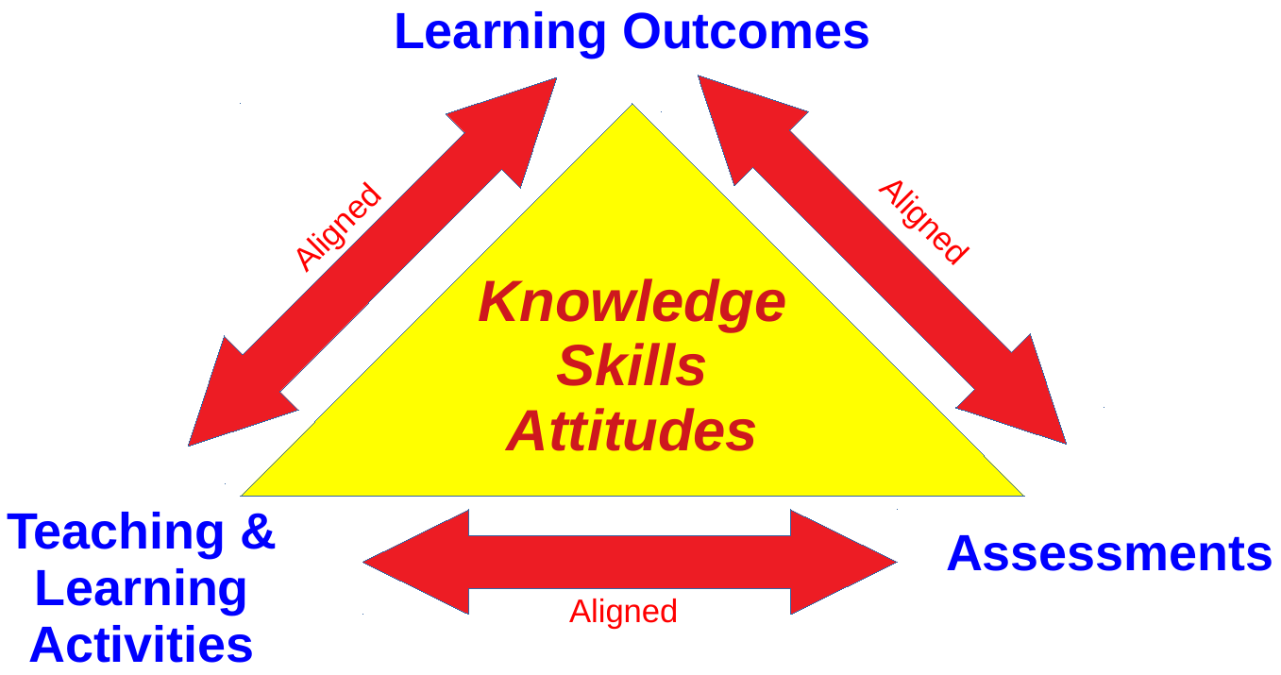

Figure: Constructive alignment of (a) learning outcomes, (b) teaching & learning activities, and (b) assessments

4 Major Steps According to John Biggs (Biggs, 2003)
- "Defining the intended learning outcomes (ILOs);"
- "Choosing teaching/learning activities likely to lead to the ILOs;"
- "Assessing students' actual learning outcomes to see how well they match what was intended;"
- "Arriving at a final grade"

References:
- Biggs, J. (2014). Constructive Alignment in University Teaching. In HERDSA Review of Higher Education, Vol I, pages 5–22. Peter Kandlbinder.
- Biggs, J. (2019). Constructive Alignment. http://www.johnbiggs.com.au/academic/constructive-alignment/.
- Biggs, J. (2003.). Aligning Teaching for Constructive Learning. Url: https://www.advance-he.ac.uk/knowledge-hub/aligning-teaching-constructing-learning
- Design Program.
- Felder, R. M. and Brent, R. (2016). Teaching and Learning STEM: A Practical Guide. Jossey-Bass, USA.

Appendix-C: Continuous Quality Improvement (CQI) Loops

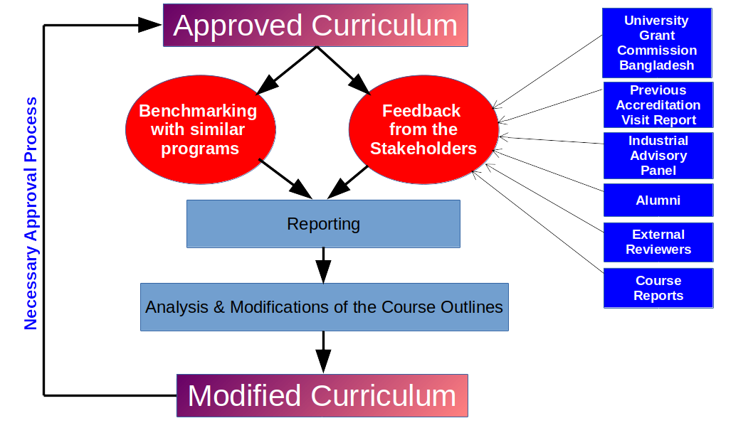

Figure C1: CQI Loop for Curriculum

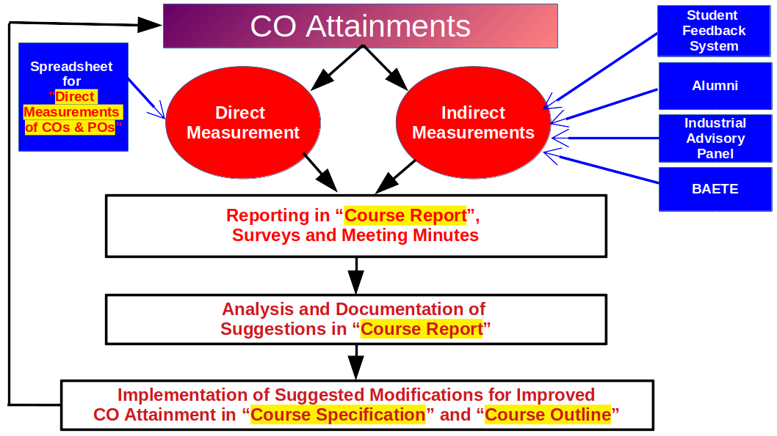

Figure C2: CQI Loop for Course Outcomes

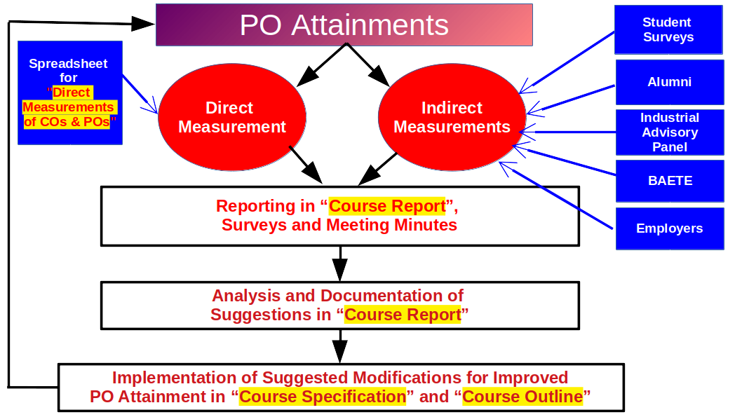

Figure C3: CQI Loop for Program Outcomes

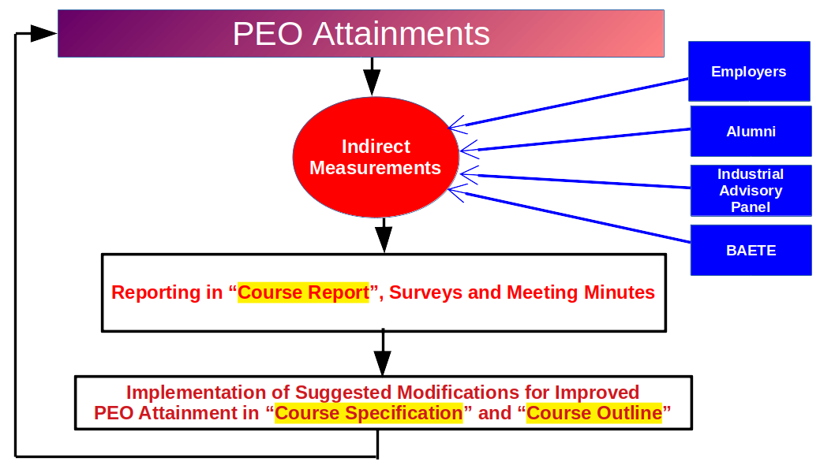

Figure C3: CQI Loop for Program Educational Objectives

