Ahsanullah University of Science and Technology

Bangladesh

COURSE SPECIFICATIONS

(Should be Submitted to the OBE Course Coordinator before the Semester Begins)

1. General Information

1.1 Course Title:

1.2 Course Code & Section:

1.3 Name of the Course Instructor :

1.4 Semester Offered:

1.5 Date of Submission :

2. Student Learning Time (SLT)

A. Face to Face Instructions | Allocated Hours = 42
A.1 Instructor-Oriented
Lecture
A.2 Student-Oriented
Active learning
B. Independent Learning | Estimated Hours
B.1 Reading and revision
Learning hours for comprehension of lecture topics
B.2 Estimated Hours for Preparation for assessments
Quizzes
Assignment
Final Examination
C. Assessment Outside Instruction Hours | Allocated Hours
Final Examination
Total SLT | 120

3. Constructive Alignment

3.1. Statement of COs*

CO No. | CO statement | Corresponding PO No. | Bloom’s Taxonomy |  |  |  | Delivery Methods and Activities |  | Assessment Method
 |  |  | C | A | P

* This table should be filled out carefully through constructive alignment

4. Teaching & Learning Activities

4.1. Planned Contact Hours for Different Topics

Sl. No. | Topics | Planned Contact Hours
 | Total

5. Assessments

5.1. Assessment Blueprint

CO No. | Assessment Item | % of Total Marks | Bloom’s Taxonomy
 |  |  | Cognitive | Affective | Psychomotor

6. Continuous Quality Improvement (CQI) Measures

6.1 Recommendations from the Previous Course Report (if any)

Loop | Assessment Type | Recommended Actions for Quality Improvement | Actions reflected in the Current Course Specification
A. CQI Loop for COs | Direct Measurement
Indirect Measurement from Surveys
(if any)
B. CQI Loop for POs | Direct Measurement
Indirect Measurement from Surveys
(if any)
C. CQI Loop for PEOs | Indirect Measurement from Surveys  (if any)

6.2 Any Other Modification (if any)

……………………………………………………………………………………………………………

……………………………………………………………………………………………………………

……………………………………………………………………………………………………………

……………………………………………………………………………………………………………

……………………………………………………………………………………………………………

……………………………………………………………………………………………………………

……………………………………………………………………………………………………………

Prepared by:

Signature: __________________

Name of the Instructor:

Department:

Date:

Appendix A: Constructive Alignment

- "In constructive alignment, we start with the outcomes we intend students to learn, and align teaching and assessment to those outcomes" (Biggs, 2019)
- "an example of outcome-based education" (Biggs, 2019)
- "If you write learning objectives and use them appropriately, your course will be in constructive alignment (Biggs, 1999) with lessons, class activities, assignments, and tests all pointing toward the same knowledge and skills" (Felder and Brent, 2016)
- "constructively aligned teaching seems to produce high quality learning outcomes and student satisfaction" Biggs (2014)

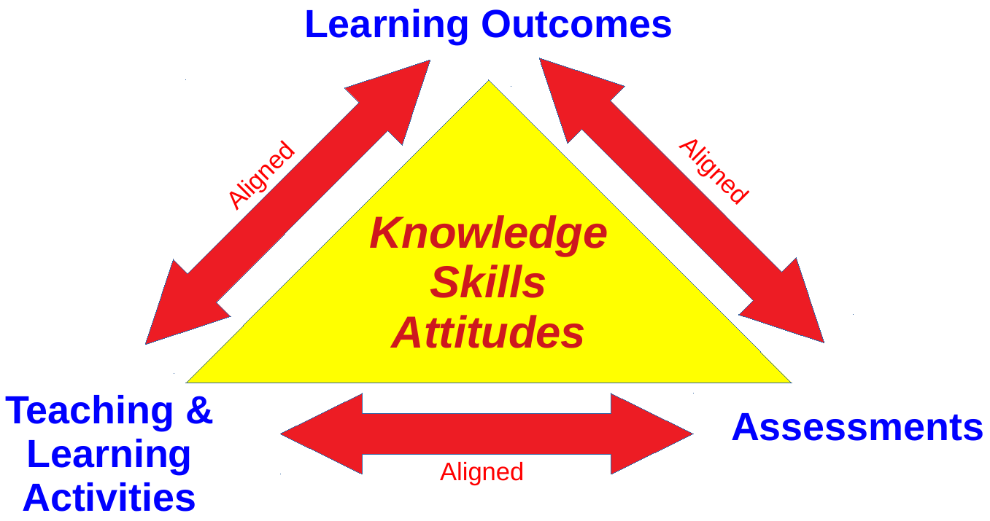

Figure: Constructive alignment of (a) learning outcomes, (b) teaching & learning activities, and (b) assessments

4 Major Steps According to John Biggs (Biggs, 2003)
- "Defining the intended learning outcomes (ILOs);"
- "Choosing teaching/learning activities likely to lead to the ILOs;"
- "Assessing students' actual learning outcomes to see how well they match what was intended;"
- "Arriving at a final grade"

References:
- Biggs, J. (2014). Constructive Alignment in University Teaching. In HERDSA Review of Higher Education, Vol I, pages 5–22. Peter Kandlbinder.
- Biggs, J. (2019). Constructive Alignment. http://www.johnbiggs.com.au/academic/constructive-alignment/.
- Biggs, J. (2003.). Aligning Teaching for Constructive Learning. Url: https://www.advance-he.ac.uk/knowledge-hub/aligning-teaching-constructing-learning
- Design Program.
- Felder, R. M. and Brent, R. (2016). Teaching and Learning STEM: A Practical Guide. Jossey-Bass, USA.

Appendix B: Continuous Quality Improvement (CQI) Loops

